Water Resource
Singatalur Lift Irrigation Scheme – Canal Network
Client : Karnataka Neeravari Nigam Limited (KNNL)
Location: Gadag District, Karnataka State and Command Area: 35259 Ha( 87124Acres)
Length of Canal: 66 Km and Length of Distributary Network: 250 Km
Lift Height: 105 m and Discharge: 15.38 Cumecs
Project Brief :
KNNL has taken up the proposal of irrigating the draught prone area in Gadag District by lifting water in three stages to the command area.
EIT has been appointed as Consultants for Survey, investigation, preparation of drawings, estimates and DTP for the above work.
Project cost: 3,800 crores
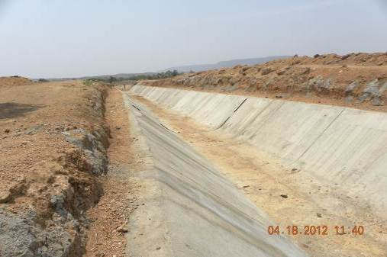 | 